FORNAX™ ePlanCheck Rule
Rule Information
Rule ID | SSW 3.1.2 (n)
Rule Name | Drain-line Connection to Sewer
Chapter | 3. Sanitary Works
Section | 3.1 Sanitary Drainage System
Handbook | Code of Practice on Sewerage and Sanitary Works  Addendum No. 2 – Nov 2004

Rule Description
3.1.2 Design Criteria

(n) For drain-line connection from the last inspection chamber to an existing 150mm diameter sewer via raised
junction or ‘Y’ junction, it shall follow the size of the existing 150mm diameter sewer.

Rule Interpretation
- This rule checks for the diameter of the Drain-line pipe or referred to as the Sewer Connection that connects the last inspection chamber to the sewer line where the connection method is via Raised Junction or Y-Junction.
- The diameter of the Sewer Connection pipe should be exactly 150 mm.

EXISTING PUBLIC SEWER LINE
= 150mm Ø
Y JUNCTION
DIAMETER
= 150MM
EXISTING PUBLIC SEWER LINE
= 150mm Ø
DRAIN LINE OR SEWER CONNECTION

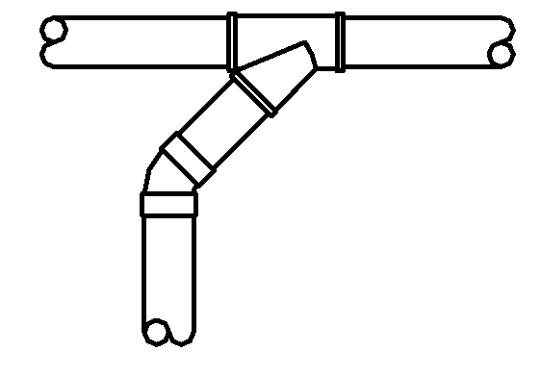
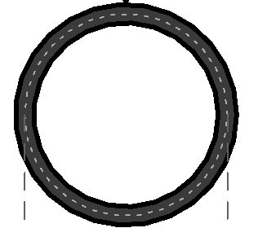

DIAMETER
= 150MM

DRAIN LINE OR SEWER CONNECTION
= 150mmØ

CROSS SECTION OF DRAIN LINE PIPE
PLAN
FIGURE 02
FIGURE 01

Rule Scenario

Scenario 01-Compliant 1
Requirement | Connecting the Sewer Connection line from the last inspection chamber to the public sewer line using Y junction.
Conditions | N.A.
Description | Sewer Connection pipe diameter = 150mm from the last Inspection Chamber connected to 150mm diameter public sewer line through a 150x150mm Y Junction.
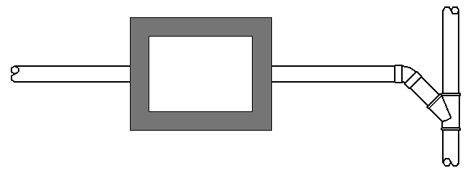
SEWER CONNECTION PIPE DIAMETER
= 150mm

PUBLIC SEWER LINE (150mm DIA.)
DRAIN-LINE
(LAST)
INSPECTION
CHAMBER

Y JUNCTION =150X150MM

PLAN
FIGURE SCENARIO

Scenario 01-Compliant 2
Requirement | Connecting the Sewer Connection line from the last inspection chamber to the public sewer line using Raised junction.
Conditions | N.A.
Description | Sewer Connection pipe diameter = 150mm from the last Inspection Chamber connected to 150mm diameter public sewer line through a 150x150mm Raised Junction.
PUBLIC SEWER LINE
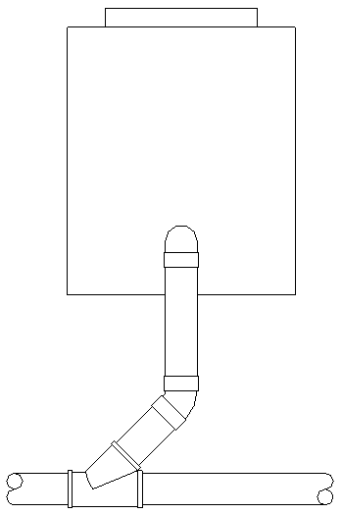
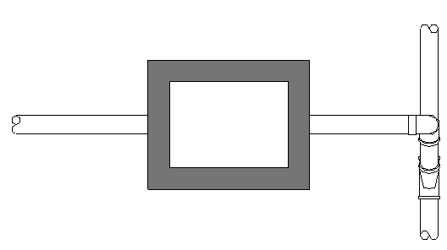
FRONT
ELEVATION
(LAST)
INSPECTION
CHAMBER
DRAIN PIPE
(LAST)
INSPECTION
CHAMBER
PLAN
SEWER CONNECTION PIPE DIAMETER
= 150mm

SEWER CONNECTION PIPE DIAMETER
= 150mm

RAISED JUNCTION =150X150MM
PUBLIC SEWER LINE
(150mm DIA.)
FIGURE SCENARIO
FRONT ELEVATION

Scenario 01-Non-compliant
Requirement | Connecting the Sewer Connection line from the last inspection chamber to the public sewer line using Y junction.
Conditions | N.A.
Description | Sewer Connection pipe diameter = 100mm from the last Inspection Chamber connected to 150mm diameter public sewer line through a 100x150mm Reducer Y Junction.
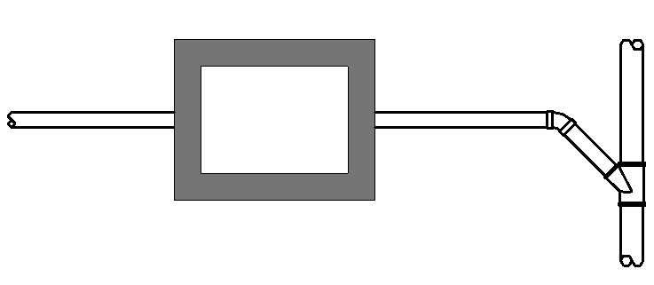
SEWER CONNECTION PIPE DIAMETER
= 100mm

PUBLIC SEWER LINE (150mm DIA.)
DRAIN-LINE
(LAST)
INSPECTION
CHAMBER

Y JUNCTION =100X150MM

PLAN
FIGURE SCENARIO

Model PreCheck

Required Elements | Required Attributes
PipeSegment | IfcDescription contains “Sewer Connection”
DistributionChamberElement | IfcName contains “Inspection Chamber”
PipeSegment | IfcDescription contains “Public Sewer Line”
PipeFitting | IfcName contains “Y Junction”, “Raised Junction”

Rule Parameters

System Type
Cold Water
Hot Water
 | Sanitary
 | Sewerage | 
Vent

Element Type 1
State | Type | Property | Operator | Value
Include | PipeSegment | IfcDescription | Contains | Sewer Connection
Exclude |  | Any | Match | N.A.
 |  | Name | N.A. | <User defined>

Element Type 2
State | Type | Property | Operator | Value
Include | DistributionChamberElement | Name | Contains | Inspection Chamber
Exclude |  | Any | Match | N.A.
 |  |  | N.A. | <User defined>

Element Type 3
State | Type | Property | Operator | Value
Include | PipeSegment | IfcDescription | Contains | Public Sewer Line
Exclude |  | Any | Match | N.A.
 |  | Name | N.A. | <User defined>

Element Type 4
State | Type | Property | Operator | Value
Include | PipeFitting | IfcName | Contains | Y Junction
Include | PipeFitting | IfcName | Contains | Raised Junction
Exclude |  | Any | Match | N.A.
 |  | Name | N.A. | <User defined>

Element Type 1 Condition
Should be exactly | 150 | mm diameter
* Equal sizes to Element Types 1, 3 and 4
* Should be connected to Element Types 2 and 3
* Nearest Element Type 2 to Element Type 3 only

Result Messages
- 3.1.2 (n) Sewer Connection to Sewer Line via Raised Junction
- Non-compliant (TotalResultNumeric)
- BuildingStorey (TotalResultPerFloorNumeric)
  - ElementNameNumeric: Diameter = ResultValueNumeric mm
- Compliant (TotalResultNumeric)
- BuildingStorey (TotalResultPerFloorNumeric)
  - ElementNameNumeric: Diameter = ResultValueNumeric mm
- Attention (TotalResultNumeric)
- BuildingStorey (TotalResultPerFloorNumeric)
  - ElementNameNumeric: No connection to sewer lines

Sample Result Messages
- 3.1.2 (n) Sewer Connection to Sewer Line via Raised Junction
- Non-compliant (1)
- Level 1 (1)
  - Sewer Connection Pipe 1.01: Diameter = 100 mm
  - Y Junction/Raised Junction is not provided
- Compliant (1)
- Level 1 (1)
  - Sewer Connection Pipe 1.02: Diameter = 150 mm
  - Y Junction/Raised Junction is provided
- Attention (1)
- Level 1 (1)
- Sewer Connection Pipe 2.01: No connection to sewer line or last IC

Sample Result Model Views
- 3.1.2 (n) Sewer Connection to Sewer Line via Raised Junction
- Non-compliant
- Plan view.
- Highlight checked element/space.
- All other elements are translucent except checked element/space.
- Compliant
- Plan View.
- Highlight checked element/space.
- All other elements are translucent except checked element/space.

Testing Scenario Notes
- Scenario 01-Compliant 1
- Level 1
- Series of Inspection chamber is located within a lot with the last chamber with a few distances from the nearest Boundary Line. The Sewer Connection pipe that connects the last chamber to the public sewer line has a size of 150mm diameter and is connected by a Y-junction pipe fitting.

- Scenario 01-Compliant 2
- Level 1
- Series of Inspection chamber is located within a lot with the last chamber with a few distances from the nearest Boundary Line. The Sewer Connection pipe that connects the last chamber to the public sewer line has a size of 150mm diameter and is connected by a Raised junction pipe fitting.

- Scenario 01-Non-compliant
- Level 1
- Series of Inspection chamber is located within a lot with the last chamber with a few distances from the nearest Boundary Line. The Sewer Connection pipe that connects the last chamber to the sewer line has a size of 100mm diameter and is connected by a 100x150mm dia. Y-junction Reducer.

Model:
SSW 312n-01-C1_v4.ifc
SSW 312n-01-C2_v4.ifc
SSW 312n-01-NC_v4.ifc

Modelling Guideline
- Specify IfcDescription containing “Sewer Connection” for relevant PipeSegment.
- Specify IfcDescription containing “Drain Line” for relevant PipeSegment.
- Specify IfcDescription containing “Public Sewer Line” for relevant PipeSegment.
- Specify IfcName containing “Y Junction” for relevant PipeFitting.
- Specify IfcName containing “Raised Junction” for relevant PipeFitting.
- Specify IfcName and IfcExportAs containing “Inspection Chamber” for relevant DistributionChamberElement.

Specification Log
RA | Alvin Q. Estocapio
Last edit date | 30 July 2018
ePC version
Updates | - V1

Specification Log
RA | Alvin Q. Estocapio
Last edit date | 10 August 2018
ePC version
Updates | - V2- Update Rule Interpretation, Model PreCheck, Rule Parameters, Result Messages and Modelling Guidelines

Specification Log
RA | Alvin Q. Estocapio
Last edit date | 10 September 2018
ePC version
Updates | - V3- Update Rule Scenario, Model PreCheck, Rule Parameters, Sample Result Model Views, Testing Scenario Notes and Modelling Guidelines

Specification Log
RA | Alvin Q. Estocapio
Last edit date | 02 October 2018
ePC version
Updates | - V4- Update rule interpretation and scenarios based on latest PUB comments scenarios; deleted “Last” from “Last Inspection Chamber”

